Sam Houston State Oboe Audition Excerpts, Spring 2025
Rossini, La Scala do Seta, Overture
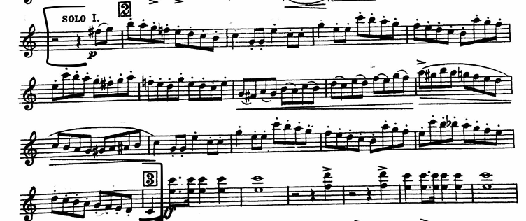
Bach, Brandenburg Concerto No. 2, Mvt. 1
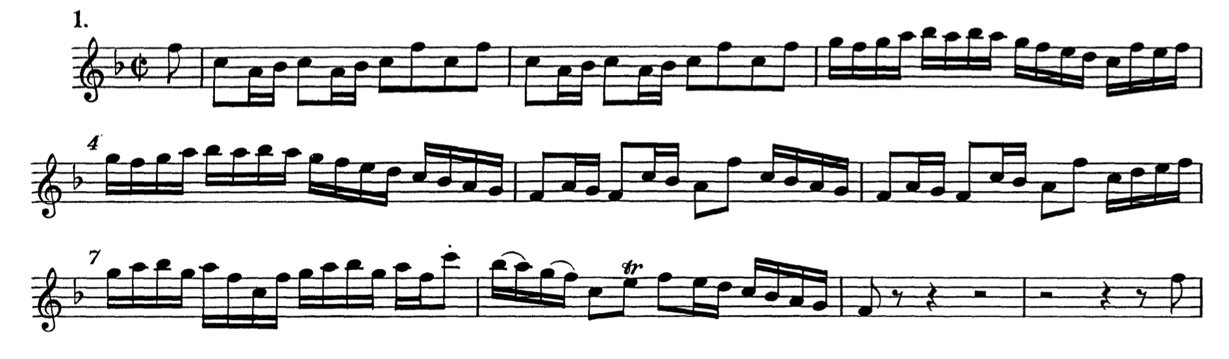
Tchaikovsky, Symphony No. 4, Mvt. 2
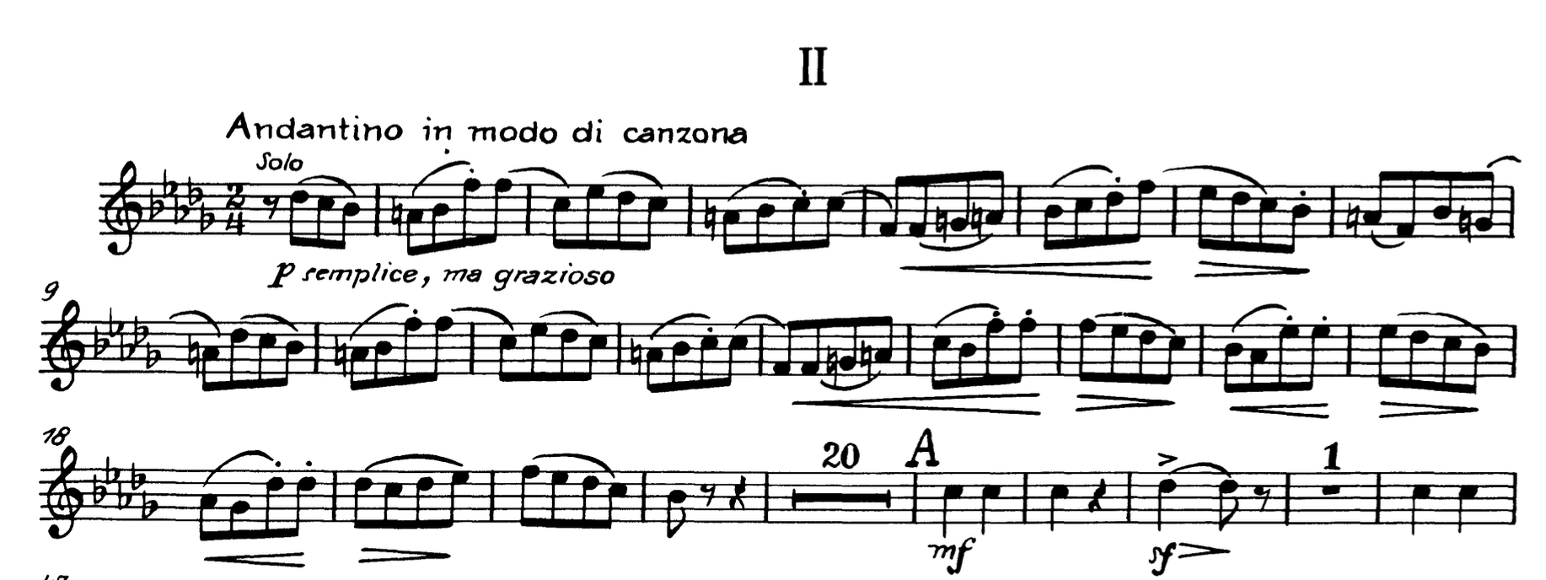

Rimsky-Korsakov, Scheherazade, Mvt. 1
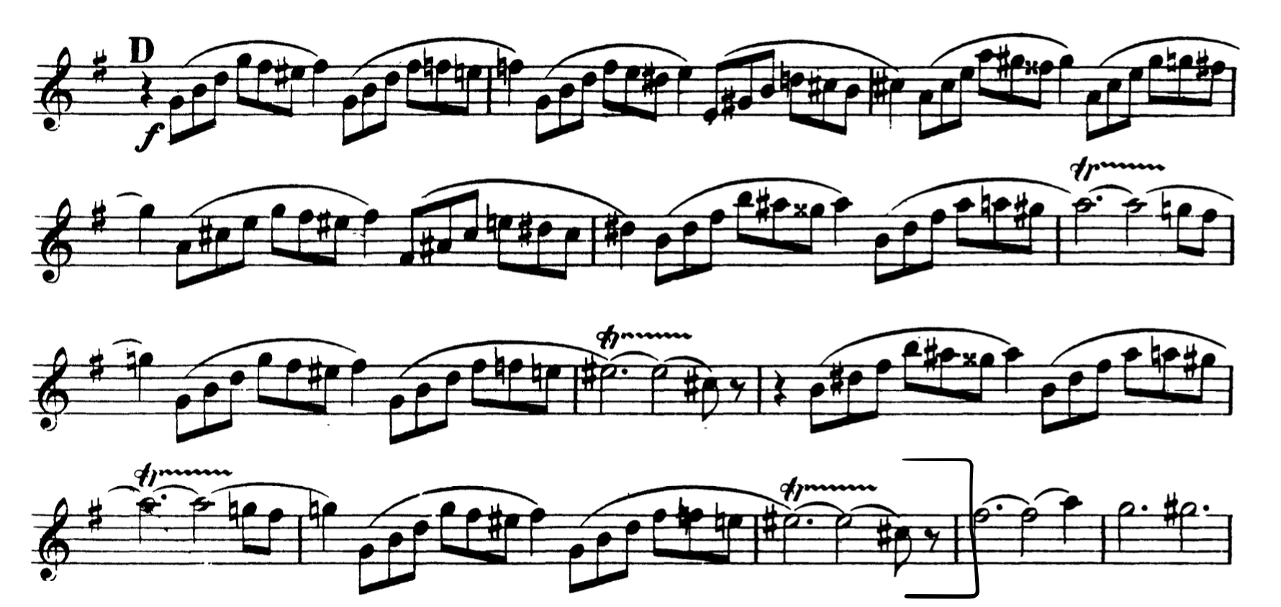
Rimsky-Korsakov, Scheherazade, Mvt. 2
